Introduction
CEN International is the creative agency tasked with supporting GMS CASP with the creative items of the 2nd AMM Meeting. The knowledge sharing zone will contain posters to feature projects from the region. The posters will be displayed in the knowledge sharing zone of the exhibition at AMM2. The posters are used as presentation tools for presenters themselves to exchange knowledge as well as self-explanatory information boards for visitors to read.

Content required
- Project Title
Training techniques on processing and use of agricultural by-products for household dairy production to minority women in Soc Trang Province
Contact person(s) and email(s)
Ms. Nguyen Thi Hong Trinh
Position: Researcher, Team Member of the Soc Trang Dairy Cow Project
Institute of Animal Science in Southern Vietnam (IASVN), MARD
Address: Hiep Thang, Binh Thang, Di An Town, Binh Duong Province
Email: trinhias@gmail.com
Tel: 0975829470

- Catchy Caption/Slogan (For example: “Pechabun Farmer Community: Working Together to Expand Market Access”
Sustainably enhancing dairy cow performance among smallholder women
- Location(s) of project (google map link)
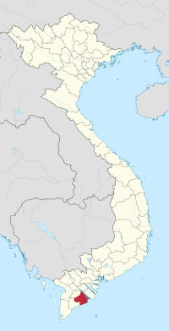
Soc Trang Province

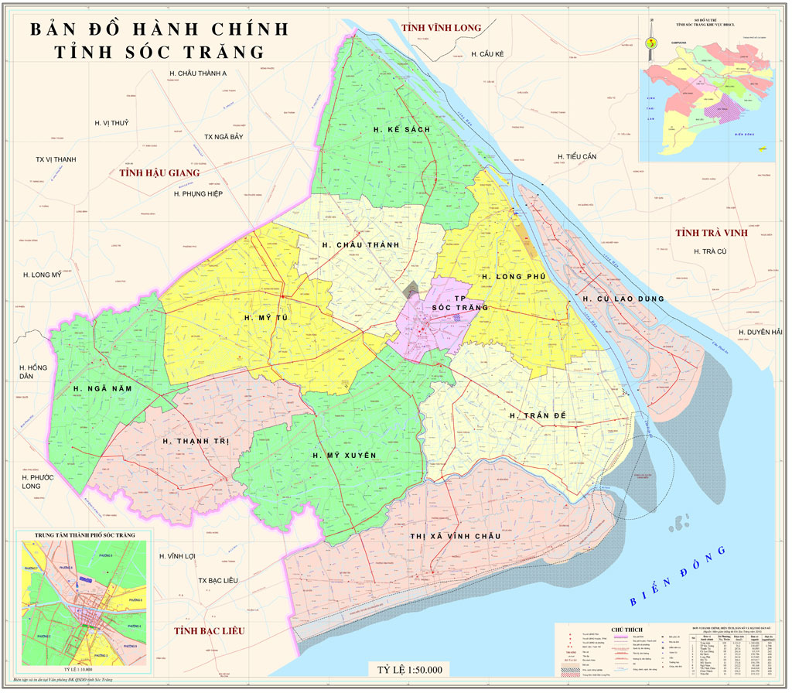
- Project Summary (110 words)
Dairy consumption in the GMS has grown dramatically over the past 20 years, and has accelerated in the past 10 years. In response to growing demand dairy production, both large-scale and smallholder, within the region has also grown at pace. This is particularly true of Viet Nam. The smallholder dairy industry in Vietnam, and specifically Soc Trang province. Between 2004 and 2014 the Soc Trang dairy herd increased from 477 head to 6161 head. The Evergrowth Cooperative had established a milk collection point in the province and were working closely with smallholder dairy farmers to establish delivery of consistently safe, high quality milk to market. However, milk yields remained low in Soc Trang relative to the national average, 3660kg/head versus 4000-4600kg/head. Furthermore, growth rates and reproduction rates were low. It was recognized that sustainably improving the productivity of smallholder dairy production in Soc Trang would have wide-reaching implications for smallholders in Viet Nam and the GMS more widely by allowing them to compete in this expanding market.
To address these problems this LOA sought to:
- Conduct a situation assessment of household dairy production in the target area and identify technical solutions to increasing milk yield and economic efficiency to sustainably contribute to increased income for smallholder dairy farmers.
- Improve smallholder dairy producer—specifically minority women dairy smallholders—technical knowledge on good animal husbrandy practices for dairy production.
- Increase profits from dairy husbandry by reducing costs and increasing production through the processing and storage of locally available agricultural by-products as improved animal feed.
- Reduce local environmental pollution and greenhouse gas emissions.
To achieve these objectives the project:
- Trained 120 dairy farming women in: the cultivation and management of feed resources and techniques for processing and using agricultural by-products; diet formulation; reproductive management; basic good animal husbandry practices
- Established three pilot sites as demonstration and training sites on improved dairy animal nutrition, reproductive management and health and environmental management.

- Any other text should be kept in short paragraphs (maximum 500 words in total)
Results:
The project model proved to be effective, increasing milk yield relative to control by 18.08% (14.88% -20.72%), reducing the calving interval by 46.7 days, increasing the utilization agricultural byproducts in diets by 10%. In addition, the model demonstrated considerable fuel savings through the use of biogas digesters and more efficient use of organic matter for fertilizer, thereby reducing local environmental pollution and greenhouse gas emissions. The project empowered the smallholder women dairy farmers who participated by increasing their knowledge and human capital, improving improving their incomes, and reducing the impact of their livelihoods on the environment in the local community.
Conclusions:
This innovative LOA project showed that smallholder dairy production in the Mekong Delta can be successful in economic terms, can empower women and vulnerable groups and can be environmentally sustainable. The key to the success of smallholder dairy is good animal husbandry, good nutrition and strong market links. The model developed in Soc Trang can be replicated in other areas of the GMS where smallholder dairy production is emerging or could emerge.

- At least 5 images, optimum are 10 images (each image with a description). Images should be high-resolution JPG
See ppts. in folder.

- Quotes and images of partners (optional) (Example: Quotes and Testimonies from Farmers and other stakeholders)
- Graphs and statistics and/or fast facts (optional)
Table 1: Feed intake
Item | Pilot | Control
Concentrate (kg/head/day) | 5.83 | 5.50
Fresh grass (kg/head/day) | 37.00 | 35.00
Urea treated rice straw (kg/head/day) | 5.00 | 0.00
Rice straw (kg/head/day) | 0.00 | 3.00
Cow weight | 456.33 | 444.97

Table 2: Milk yield and reproductive ability and benefit
Item | Pilot | Control
Number of milking cows (3cows/pilot x 3 pilots=9cows) | 9 | 9
Milk yield (kg/head/day) | 13.93 | 11.80
Following estrus after calving (day) | 108.00 | 154.67
Benefit(VND/cow/day) | 102,573 | 86,300

Table 3: Up scaling
Item | Before | The end of project | After
Percentage of dairy farms preserved straw and agricultural by-products | 39.0 | 90.0 | >95.0
Percentage of dairy farms applied urea treated rice straw and silaged agricultural by-products technique | 0 | 30.0 | 80.0
Number of households used grass chop machine | 0 | 11 | 22
Number of households used biogas system | 8 | 196 | 200

Note: Project Summary and other text should at least very briefly present/discuss on the project’s contribution towards “a more integrated, climate-friendly agricultural sector in the GMS”:
- Key findings with firm results shown
- Impacts to beneficiaries
- Potential for upscaling
- Policy implications/direction

