Introduction
CEN International is the creative agency tasked with supporting GMS CASP with the creative items of the 2nd AMM Meeting. The knowledge sharing zone will contain posters to feature projects from the region. The posters will be displayed in the knowledge sharing zone of the exhibition at AMM2. The posters are used as presentation tools for presenters themselves to exchange knowledge as well as self-explanatory information boards for visitors to read.

Content required
- Project Title
Tracing Cross Border Livestock Movement and the Risk of Spread of Foot & Mouth Disease - China-Laos & China-Myanmar Border in Yunnan Province
- Contact person(s) and email(s)
Yunnan Animal Science and Veterinary Institute (YASVI), Kunming, People’s Republic of China
Dr. Li Huachun (li_huachun@hotmail.com); Ms. Liao Defang (wenjie3@hotmail.com)
- Catchy Caption/Slogan (For example: “Pechabun Farmer Community: Working Together to Expand Market Access”
Protecting GMS livestock with Disease Control Zones
- Location(s) of project (google map link)
- Project Summary (110 words)
The project sought to identify the major cattle and buffalo movement pathways from Lao PDR and Myanmar into the People’s Republic of China through Yunnan Province, recognising that these animals may have originated in other parts of the GMS, India and Bangladesh. The project focussed on tracing animals transiting to other destinations within the PRC. The study collected movement data, sampled almost 3000 animals for FMD exposure, piloted a traceability system and identified key points along major animal movement corridors for the targeting of FMD control measures.
- Any other text should be kept in short paragraphs (maximum 500 words in total)
Foot and mouth disease (FMD) is an important transboundary animal disease that causes significant economic losses to livestock producers in the GMS by severely limiting productivity and hampering access to export markets. The disease is highly infectious and is typically spread through the movement of live animals.
The study found that over one million cattle and buffalo are exported informally from Lao PDR and Myanmar to the PRC through Yunnan (Table 1). Furthermore, a worryingly high proportion of the animals have been exposed to FMD virus serotypes O, A, Asia1 and, particularly, to type 3ABC. Moreover, using qPCR it was found that a small but significant percentage of animals were RNA positive FMD virus, thereby presenting a direct threat of virus transmission. This demonstrates that the risk of FMD spread via cattle and buffalo traded within the GMS is extremely high and thereby presents a significant threat to livelihoods and food security in the subregion.
Encouraging legal animal movement and the development of disease control zones (DCZs) along the Lao PDR–Yunnan and Myanmar–Yunnan borders presents a novel strategy to minimizing the risk of FMD spread within the GMS countries while protecting access to the enormous market for livestock products in the PRC. To function effectively, the DCZs must include animal identification and traceability systems, transparent livestock movement management systems, risk-based monitoring of animal health status, and vaccination at borders. Moreover, public and private investment in key DCZ infrastructure and allied services, such as feed lots and slaughtering facilities are needed.
The establishment of FMD-focused DCZs in Yunnan can also provide lessons and a template for the control of other production pathogens and foodborne hazards in Yunnan and the GMS more broadly. The approach can be built on and/or replicated to address the movement of pigs and poultry and the sustainable management of broader human and animal health risks associated with animal and animal product trade.
Appropriate regulation of cross-border livestock trade and the establishment of DCZs can create the incentives for legal livestock trade which will allow better management of risk to the benefit all stakeholders including consumers. In particular, establishing controlled, safe livestock trade will benefit the communities living in the border areas and support smallholder farmers and traders in Lao PDR, Myanmar and the wider GMS, many of whom are women, whose livelihoods depend on livestock raising and trade.
Effective management of animal disease risk through monitoring and control of animal movement will protect GMS food security, livelihoods and wider market access for the subregion’s animal suppliers.
- At least 5 images, optimum are 10 images (each image with a description). Images should be high-resolution JPG

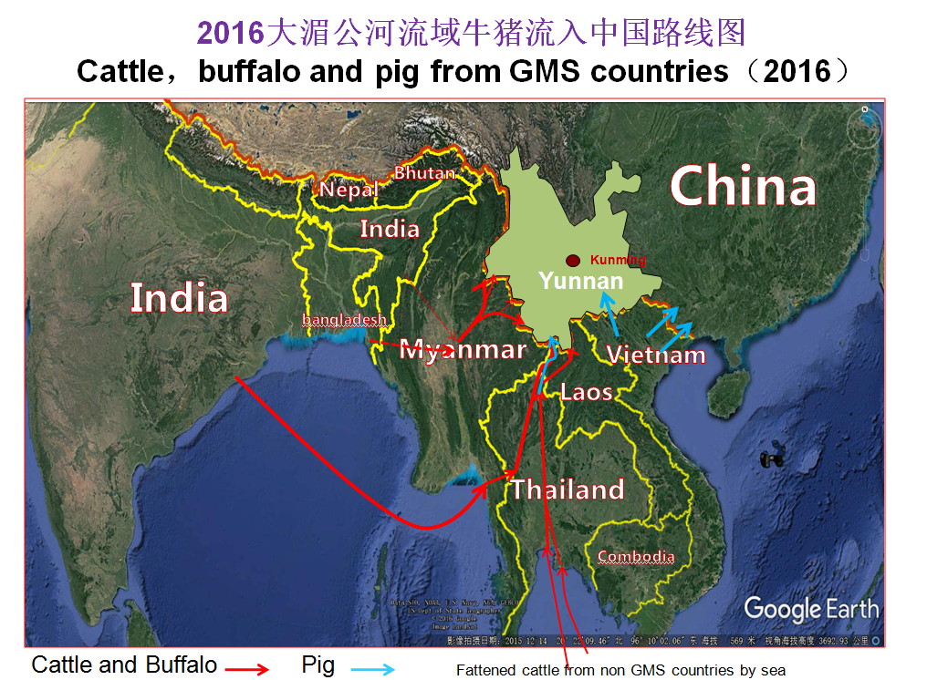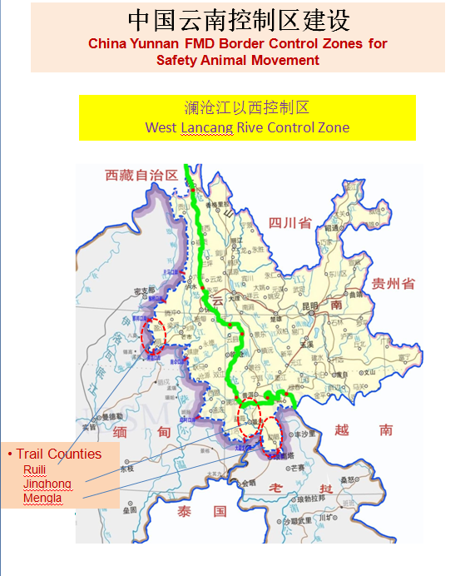
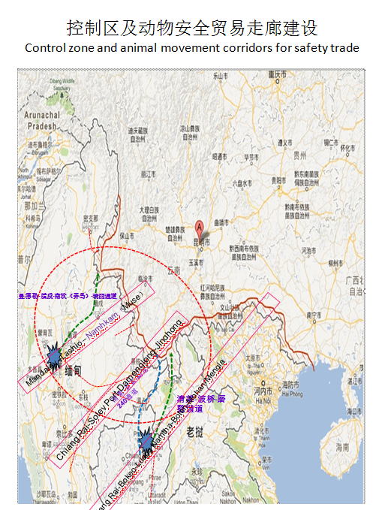
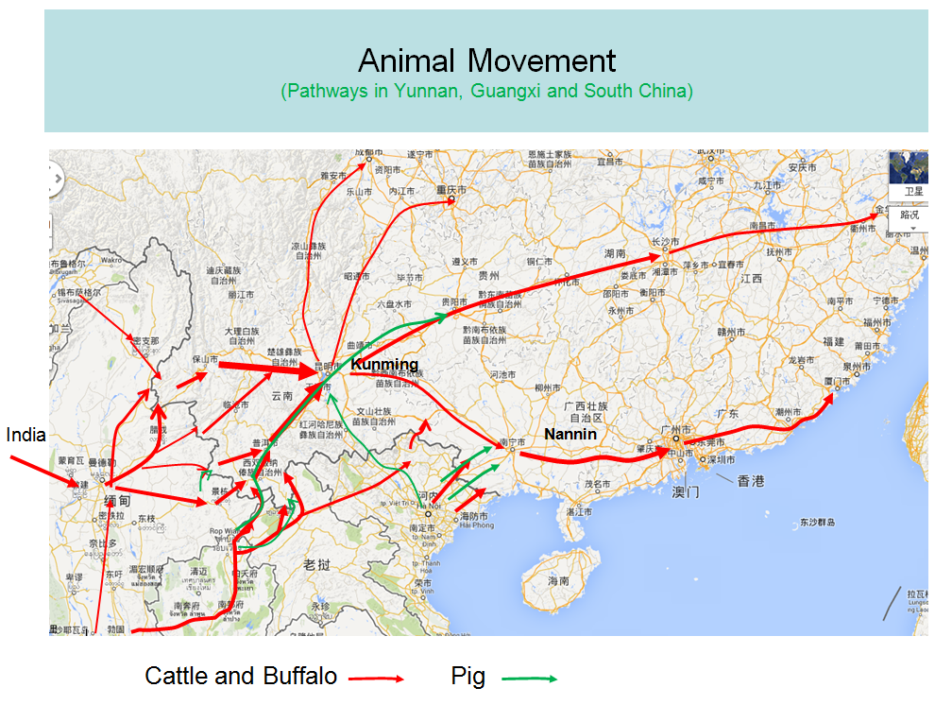

- Quotes and images of partners (optional) (Example: Quotes and Testimonies from Farmers and other stakeholders)
- Graphs and statistics and/or fast facts (optional)
Table 1. Live cattle and buffalo trade pathways into Yunnan from the GMS
Pathway | Estimated volume head/day (head/year) | Main modes of transport
Luang Namtha Province to Boten, Lao PDR  Mohan, PRC  Mengla County, Xishuangbanna Prefecture, PRC. | 300 (100,000) | Truck
Chiang Rai Province, Thailand  Soley, Myanmar  Jinghong City, PRC | 1200 (300,000) | Boat and truck
Mandalay, Lashio and Panghsang in Shan State, Myanmar  Menga Village of Mengma Township, Menglian County of Puer Municipality, PRC. | 500 (180,000) | Truck or on foot
Mandalay, Lashio, Namhkam, Muse in Shan State, Myanmar  Longdao Township of Ruili City, Dehong Prefecture, PRC | 800-1000 (300,000) | Truck or on foot
other cross-border pathways | 1000 (100,000) | Various

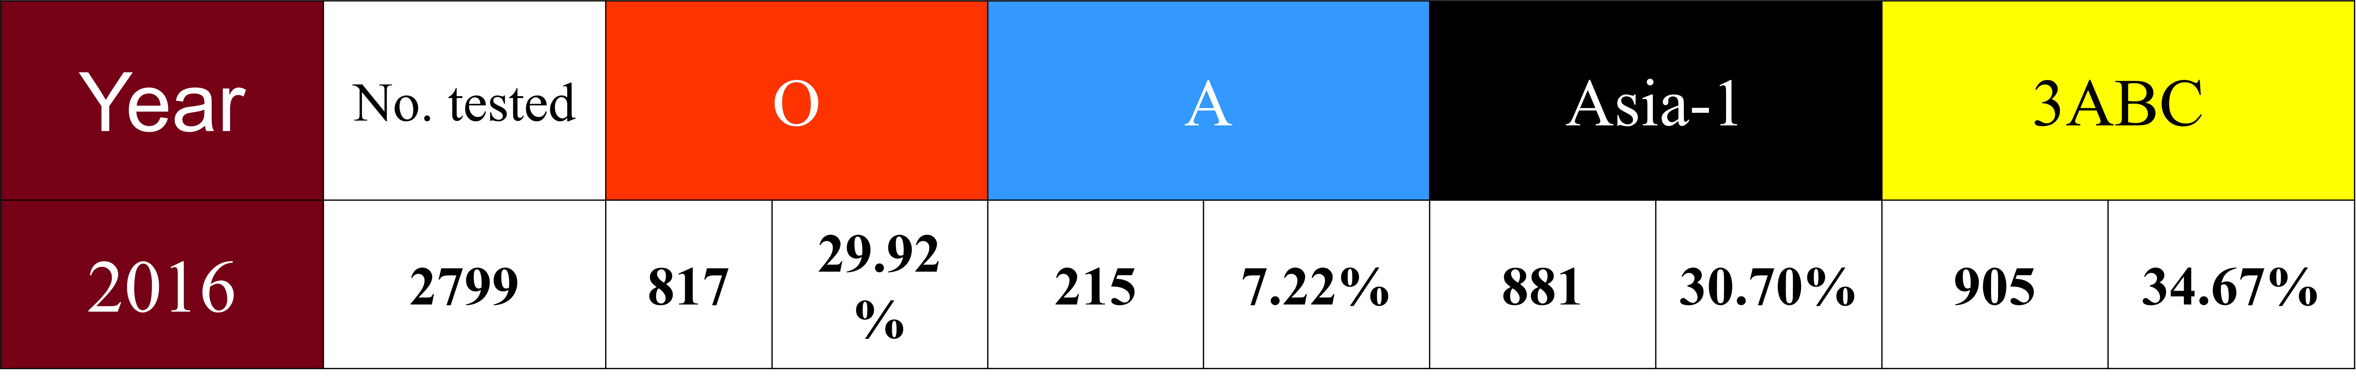
FMD virus antibodies

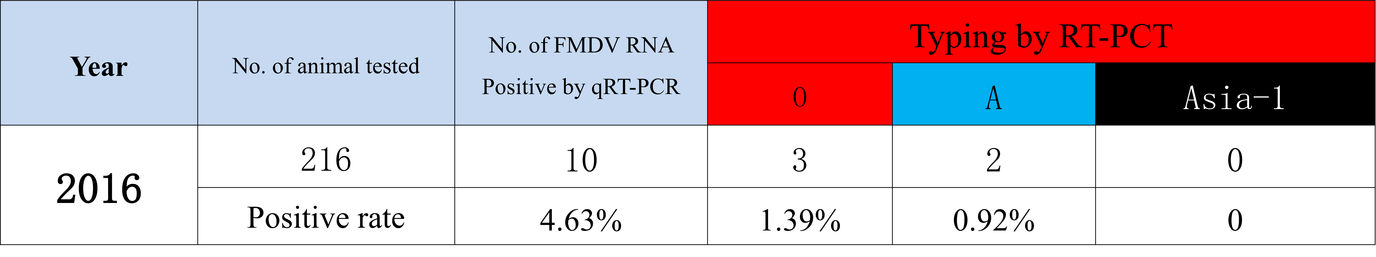
FMD virus RNA test for OP fluid

Note: Project Summary and other text should at least very briefly present/discuss on the project’s contribution towards “a more integrated, climate-friendly agricultural sector in the GMS”:
- Key findings with firm results shown
- Impacts to beneficiaries
- Potential for upscaling
- Policy implications/direction

