Introduction
CEN International is the creative agency tasked with supporting GMS CASP with the creative items of the 2nd AMM Meeting. The knowledge sharing zone will contain posters to feature projects from the region. The posters will be displayed in the knowledge sharing zone of the exhibition at AMM2. The posters are used as presentation tools for presenters themselves to exchange knowledge as well as self-explanatory information boards for visitors to read.

Content required
- Project Title: Establishment of Participatory Guarantee System-PGS in Laos
- Contact person(s) and email(s): Thavisith Bounyasouk, email: thavisithb@yahoo.co.uk
- Catchy Caption/Slogan (For example: “Pechabun Farmer Community: Working Together to Expand Market Access”
- Location(s) of project (google map link):
- Project Summary (110 words)
The project of establishment of Participatory Guarantee System (PGS) in Lao PDR is one of LOA activity under CASP 2 TA 8163-REG, aimed to establish the PGS legal framework and the PGS pilots in the country. The project selected 3 farmer groups as PGS pilots namely Huaphan Bamboo Group, Xiengkhoang Organic Farmer Association and Savannakhet Organic Farmer Group. The project worked with 280 farmers covering 17 villages of 3 three districts (Xiengxay, Kaisonphomvihanh, and Paek), with total area of 309.81 ha, and average production of 194 tons per year. The project has implemented 12 activities with total budget of 120,000 USD. Throughout project period, there were total 1,429 attendants of farmers, private sectors, NGOs and public officers. One of the main focuses of CASP2 is the adoptation of gender responsive climate- friendly agriculture so the project assured that 30% of the participants was female. At the end of project, 194 tons of produces (including bamboo shoots & vegetables), 309.31 ha, and 280 farmers, were certified by DOA as PGS.
- Any other text should be kept in short paragraphs (maximum 500 words in total)
Overall, the PGS project has supported the Lao government vision regarding clean agriculture. Although there is no activity supported directly from our Department, During October to December 2016, the certified PGS groups are still functioned and continued their activities in particularly the production and the market activities. For instance, the PGS pilots in Xiengkhoang and Savannakhet are continued to sell their products in local markets. The sell figures of vegetables at farmer markets in Xiengkhouang and Savannakhet during October to December 2016 were averaged at 12 tons and 5 tons, respectively. It can be seen that although there are no PGS activities during that period, the PGS groups are be able to sell their produces at the markets with their satisfied volume. This can be assumed that after receiving certification from Department of Agriculture, the PGS groups are recognized and gaining trust and confident from local consumers. Although, the PGS groups are functioned and linked with markets, the newly PGS pilots are required further hand-on training and coaching. The further activities needed to support PGS groups are included (the documentations, strengthening on PGS training, documentation review and renew of their certification, the meeting of PGS committee, internal auditing as well as the collaboration among public-private and community partnership.

- At least 5 images, optimum are 10 images (each image with a description). Images should be high-resolution JPG

Picture 1: Preparing bamboo shoots on the bamboo plate for drying.

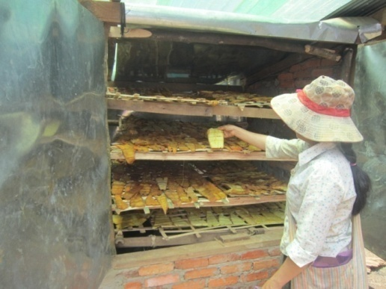
Picture 2: Drying bamboo shoots by using charcoal oven.

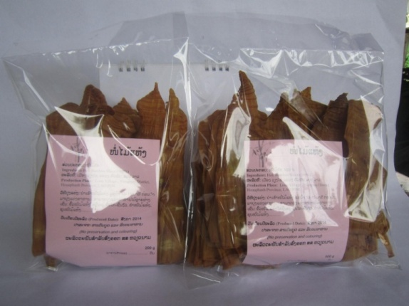
Picture 3: Dried bamboo shoot packaging for market.

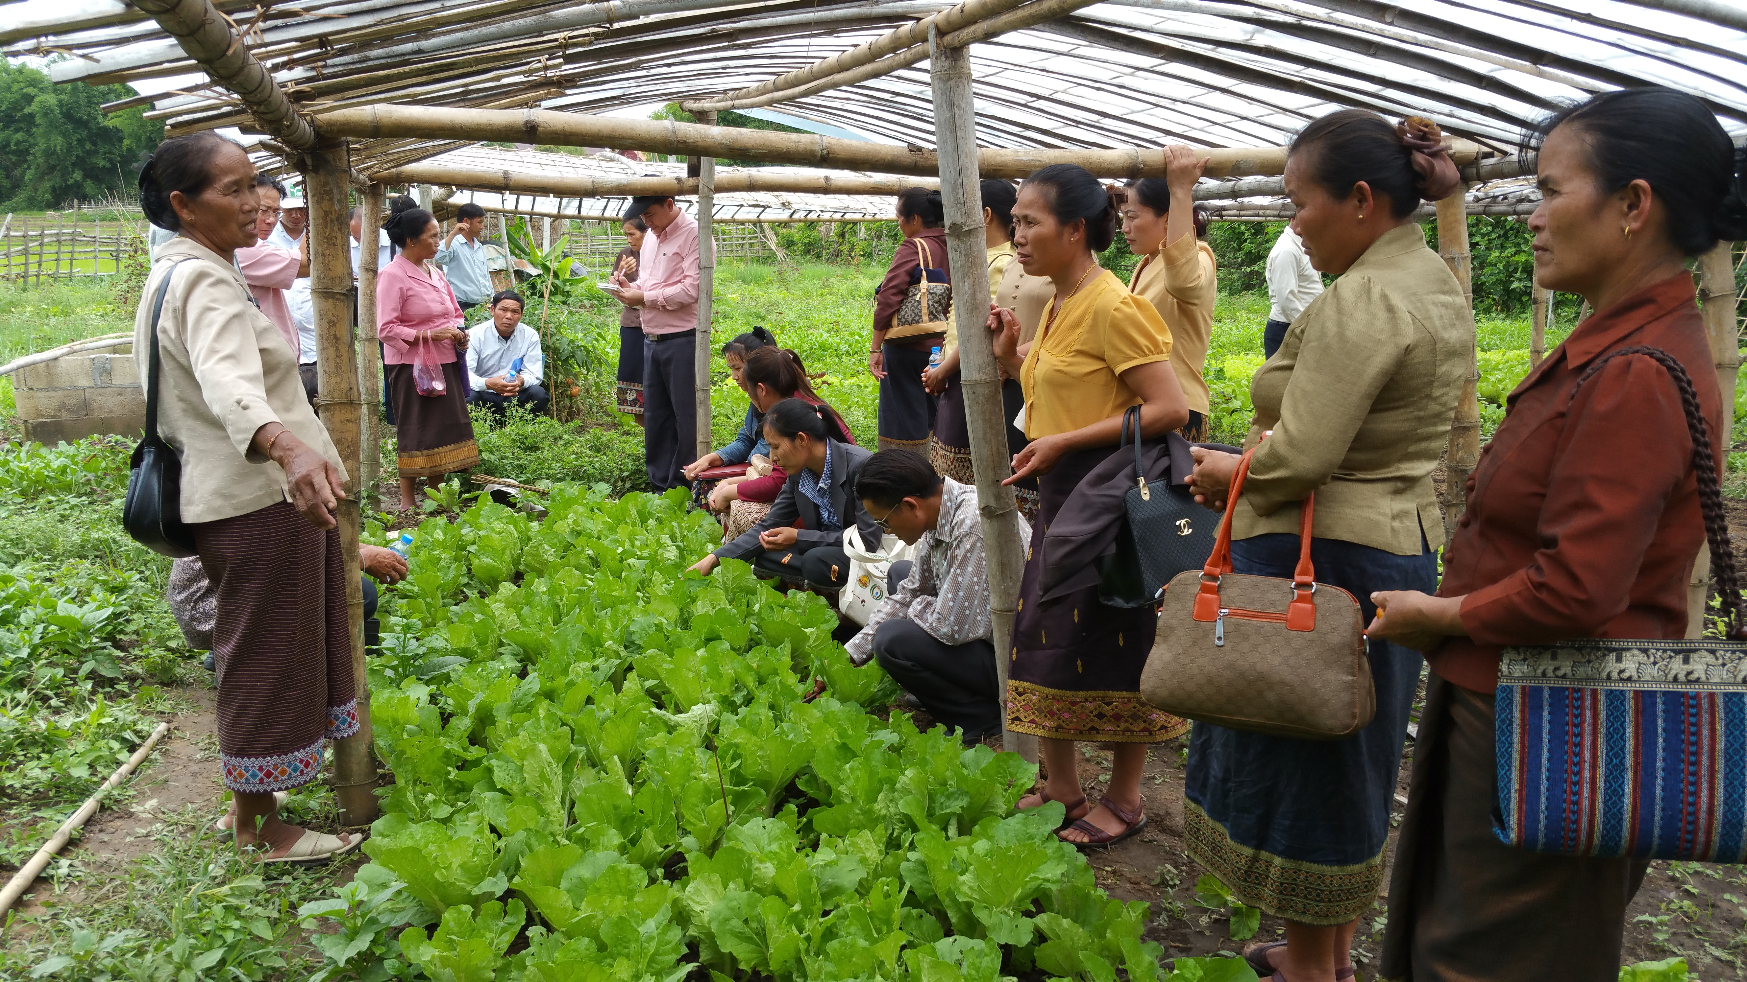
Picture 4: Hand-on training how to conduct participatory farm auditing

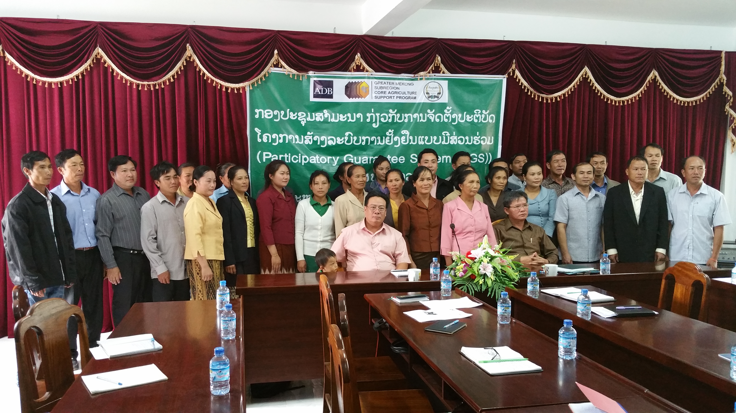
Picture 5: Introduction Workshop on PGS implementation for PGS operators

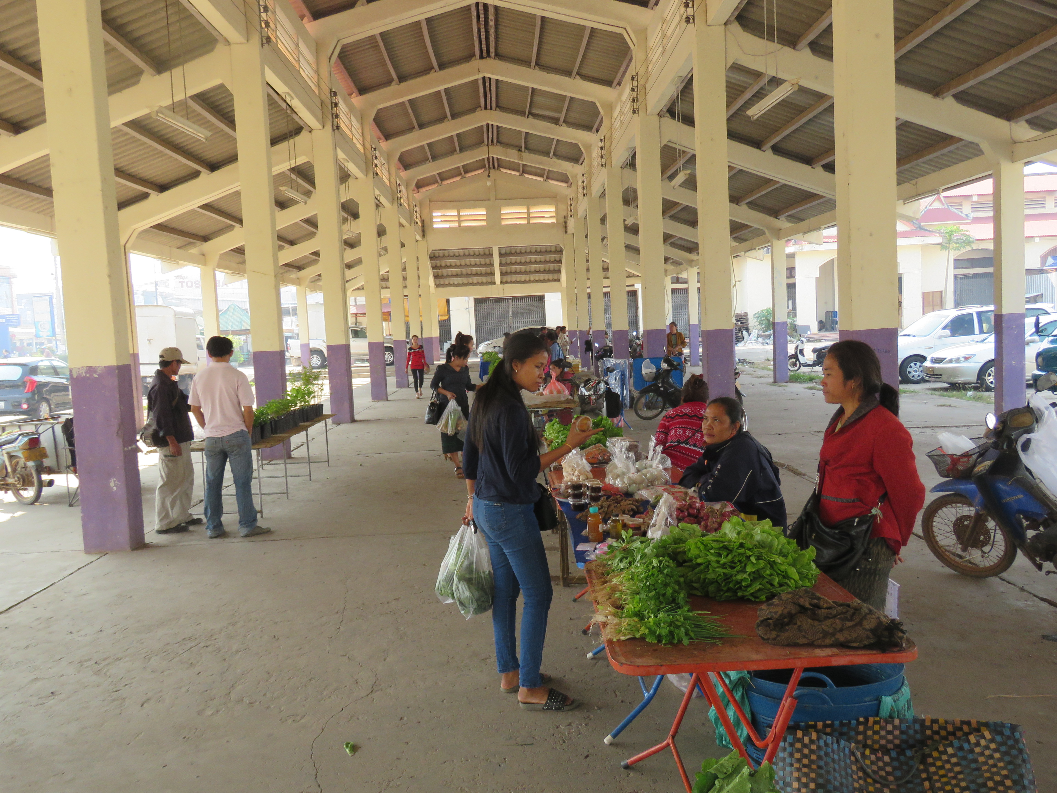
Picture 6: Farmer Organic Market, one of PGS pilot in Savannakhet province

- Quotes and images of partners (optional) (Example: Quotes and Testimonies from Farmers and other stakeholders)
- Graphs and statistics and/or fast facts (optional)
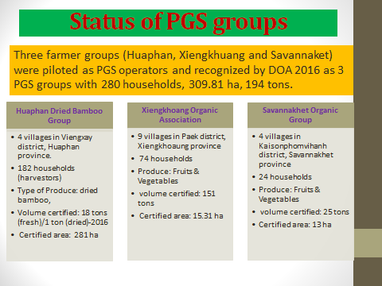
Note: Project Summary and other text should at least very briefly present/discuss on the project’s contribution towards “a more integrated, climate-friendly agricultural sector in the GMS”:
- Key findings with firm results shown
- Impacts to beneficiaries
- Potential for upscaling
- Policy implications/direction

