Introduction
CEN International is the creative agency tasked with supporting GMS CASP with the creative items of the 2nd AMM Meeting. The knowledge sharing zone will contain posters to feature projects from the region. The posters will be displayed in the knowledge sharing zone of the exhibition at AMM2. The posters are used as presentation tools for presenters themselves to exchange knowledge as well as self-explanatory information boards for visitors to read.

Content required
- Project Title:

Establishment of Participatory Guarantee System (PGS) in Laos

- Contact person(s) and email(s):

Thavisith Bounyasouk, email: thavisithb@yahoo.co.uk

- Catchy Caption/Slogan (For example: “Pechabun Farmer Community: Working Together to Expand Market Access”

Laotian PGS – inclusive and accessible food safety and quality assurance built on community-driven approaches

- Location(s) of project (google map link):

- Project Summary (110 words)

The project objective was to establish the legal framework for Participatory Guarantee System (PGS) in Lao PDR and pilot the system among farmer groups. PGS provides a novel approach to community-based, and policed, assurance of production methods in accordance with organic production methods providing. PGS is an accessible local method of demonstrating quality through robust, inclusive and peer-based internal control mechanisms. The project selected 3 farmer groups as PGS pilots, namely the Huaphan Bamboo Group, the Xiengkhoang Organic Farmer Association and the Savannakhet Organic Farmer Group. In total, the project worked directly with 280 farmers from 17 villages in one district in each province (Xiengxay, Kaisonphomvihanh, and Paek), with total cultivated or managed area of 309.81ha delivering an average production of 194 tons of produce to market per group per year. The project has implemented 12 activities with total budget of 120,000 USD. 1,429 farmers, private sector representatives, NGOs and public officers who attended project events such as trainings. A key focus of the project was gender responsive climate- friendly agriculture, 30% of the participants were female. By the end of project all 280 farmers and the produce of all 309.31 ha were certified as meeting the requirements of PGS for the Lao PDR Department of Agriculture.

- Any other text should be kept in short paragraphs (maximum 500 words in total)

The PGS project supported the Lao PDR government’s vision of establishing the country as a supplier of clean agricultural products. The PGS groups established under the LOA have proven to be robust, inclusive and sustainable helping generate consistent incomes for smallholders. A testament to the success of the project is that the three PGS groups have continued to operate without support since the conclusion of the project, both in terms of quality assurance and marketing initiatives. Demonstrating the sustainability of the systems, the PGS groups are still able to sell their produce to the standards required by their buyers. For instance, the PGS pilots in Savannakhet and Xiengkhoang continue to sell their products in local markets, selling 5 and 12 tons, respectively. The PGS bamboo shoots now have a sustainable approach to bamboo shoot production a stable, lucrative market across the Lao PDR-Viet Nam border to the increasingly well-known Vietnamese grocer Bac Tom, that specialize in selling only safety and quality assured produce. PGS products are also becoming increasingly widely recognized among local consumers who trust the approach, a step towards the generation of appropriate price premiums for producers of products that have assured qualities.

This project demonstrated that the PGS approach empower women and support food security and poverty and vulnerability reduction through the generation of sustainable livelihoods. PGS can generate incomes while protecting natural capital and generating social capital within communities.

In spite of the successes of the PGS groups established under this LOA, they do require further hands-on training and support to continue to develop their markets. Moreover, there is great potential to replicate the PGS model in other areas of Lao PDR and the GMS.

At this stage, it is essential that the successful PGS models are reviewed critically and lessons are drawn for future initiatives for future PGS group establishment and development are drawn. In addition, documented best practices for establishing PGS groups are needed to encourage further adoption and ensure that PGS is employed systematically and fairly to protect the name of PGS and the burgeoning market for PGS produced products. and approaches to developing additional PGS groups. Further training in PGS establishment and application are needed to upskill and integrate new farmers. PGS certifications will also require renewal, which involves inspection of production records and field visits to farms.

This project has demonstrated the potential value of PGS for cost effectively establishing a community-led process to develop food safety and quality assurances to buyers and end-consumers. Leveraging appropriate price premiums that adequately reward suppliers is the next step. This pilot has demonstrated the potential value of the PGS model to smallholders and can be readily replicated in other parts of Lao PDR and around the GMS. The Loa PDR project implementers can also learn a great deal from countries with more advanced PGS systems within the subregion, such as Viet Nam, and internationally.

- At least 5 images, optimum are 10 images (each image with a description). Images should be high-resolution JPG

Picture 1: Preparing bamboo shoots on the bamboo plate for drying.

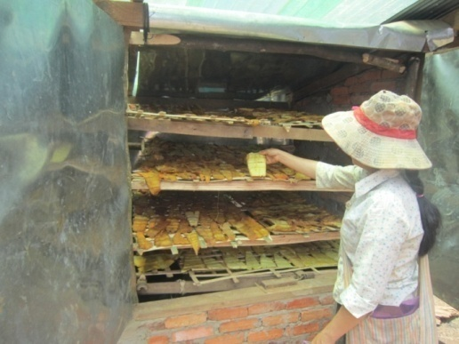
Picture 2: Drying bamboo shoots by using charcoal oven.

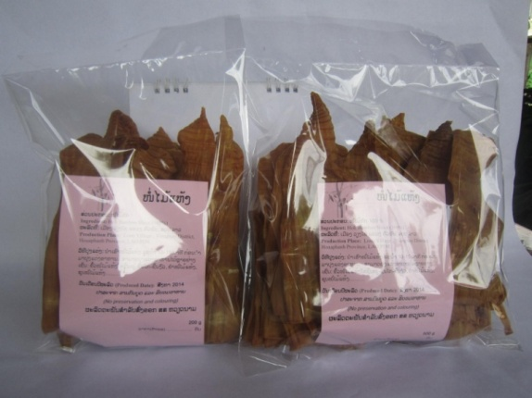
Picture 3: Dried bamboo shoot packaging for market.

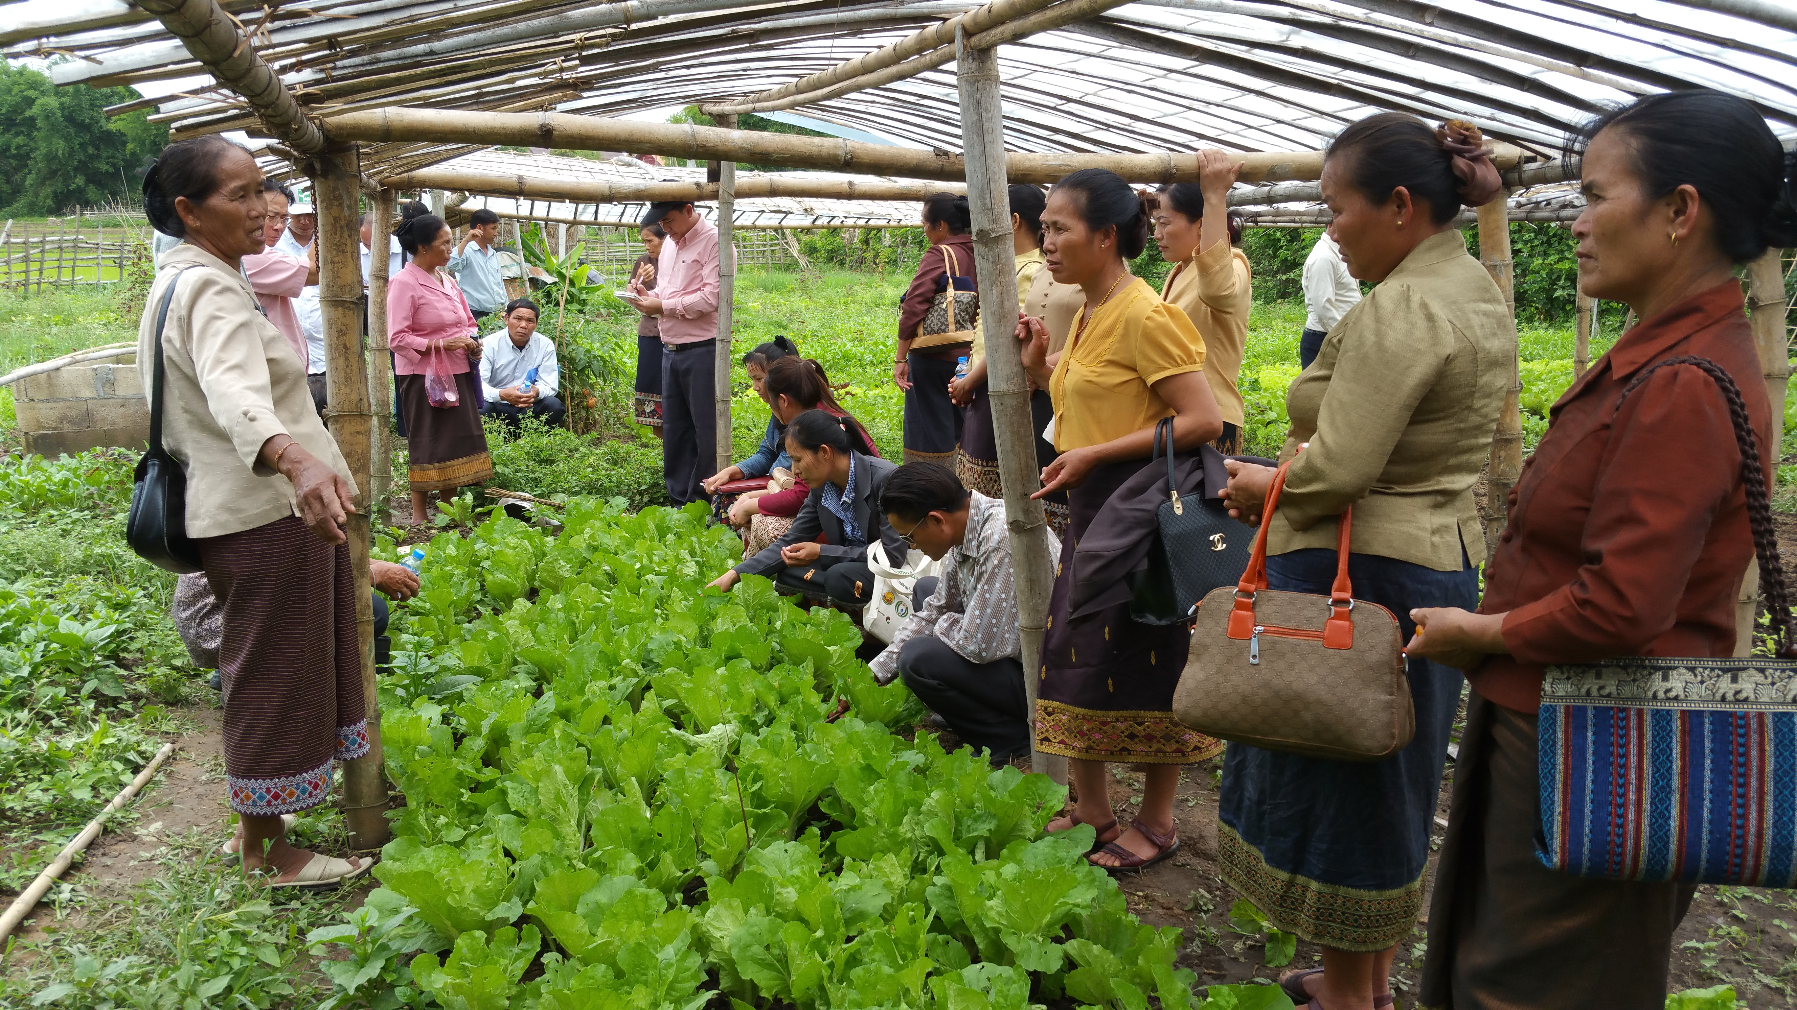
Picture 4: Hand-on training how to conduct participatory farm auditing

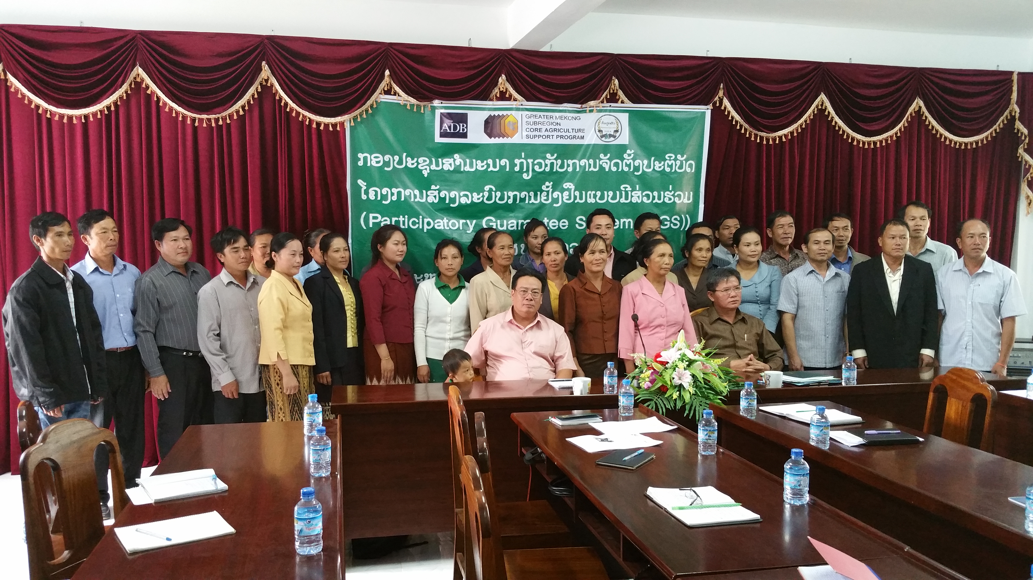
Picture 5: Introduction Workshop on PGS implementation for PGS operators

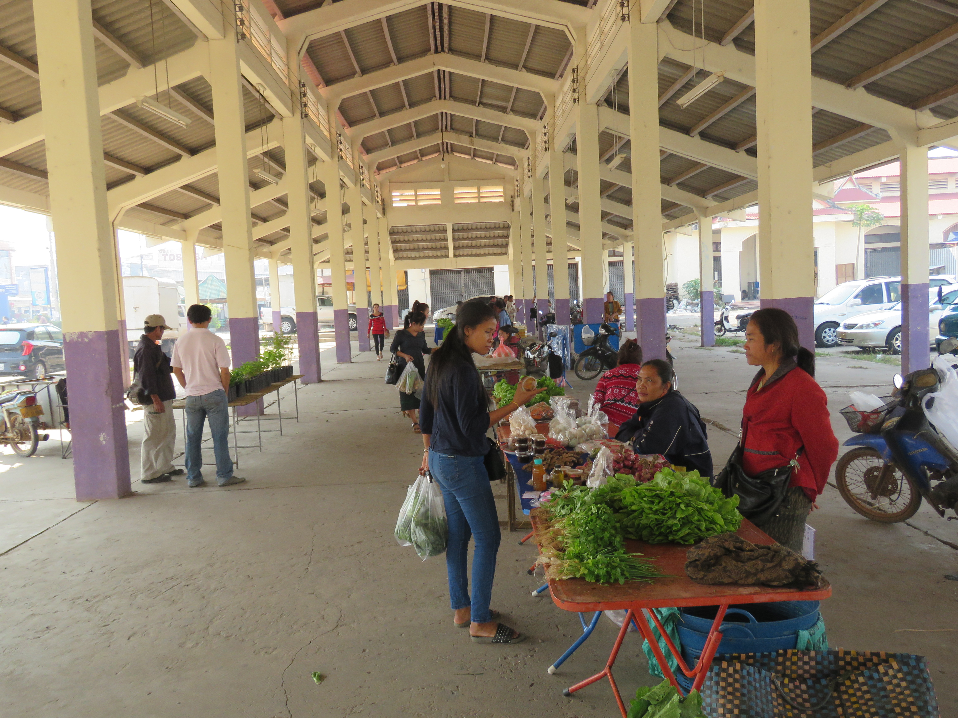
Picture 6: Farmer Organic Market, one of PGS pilot in Savannakhet province

- Quotes and images of partners (optional) (Example: Quotes and Testimonies from Farmers and other stakeholders)
- Graphs and statistics and/or fast facts (optional)
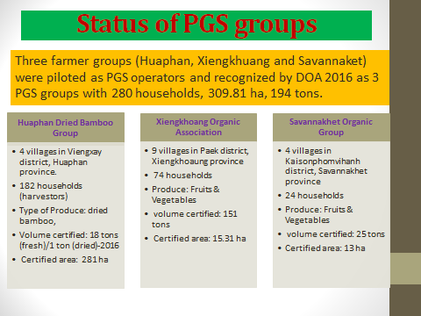
Note: Project Summary and other text should at least very briefly present/discuss on the project’s contribution towards “a more integrated, climate-friendly agricultural sector in the GMS”:
- Key findings with firm results shown
- Impacts to beneficiaries
- Potential for upscaling
- Policy implications/direction

