- Project Title: GREEN WATER MANAGEMENT FOR SUSTAINABLE AGRICULTURE IN DROUGHT ZONES OF LAOSdddd
- Contact person and email:
Dr Nivong Sipaseuth, email: sinavong@gmail.com
Thisadee Chounlamountry, email: thisadeec@hotmail.com
Department of Agriculture Land Management (DALaM)
Mobile phone: (+856) 2055133550
- Catchy Caption/Slogan: Water and Soil is life, conserve it
- Location of the project:
- Khammuon province
https://www.google.la/maps/place/Khammouane+Province/@17.6250697,104.585211,296990m/data=!3m1!1e3!4m5!3m4!1s0x31394e912b041533:0xf4c3a45264b6d1e1!8m2!3d17.6384066!4d105.2194808?hl=en
Sebanfai District
Nongbok District

- Savanakhet province
https://www.google.la/maps/place/Savannakhet+Province/@16.496921,105.203283,173358m/data=!3m2!1e3!4b1!4m5!3m4!1s0x313dc60688062c13:0xff13318c5ce5dc74!8m2!3d16.5065381!4d105.5943388?hl=en
Kaison District
https://www.google.la/maps/place/Savannakhet/@16.5669366,104.69803,21662m/data=!3m2!1e3!4b1!4m13!1m7!3m6!1s0x313dc60688062c13:0xff13318c5ce5dc74!2sSavannakhet+Province!3b1!8m2!3d16.5065381!4d105.5943388!3m4!1s0x313dc5e0e65d9353:0xd7aa0b924e1d8a3f!8m2!3d16.5717065!4d104.7711182?hl=en
Champhon District
Songkhon District
- Salavan province
https://www.google.la/maps/place/Salavan+Province/@15.88333,105.7866599,146628m/data=!3m1!1e3!4m5!3m4!1s0x311558d39704508b:0x3d025666be56beb0!8m2!3d15.8171073!4d106.2522143?hl=en
Lakhonpeng
https://www.google.la/maps/place/Lakhonepheng/@15.9388392,105.3444025,5433m/data=!3m2!1e3!4b1!4m5!3m4!1s0x3115f507b91d9e17:0xa286dc20792d21cc!8m2!3d15.9375242!4d105.3628846?hl=en
- Project Summary
The Green Water Management (GWM) project is the first project of Core Agricultural Support Program Phase 2 (CASP2) under ADB TA 8163 to systematically address gaps in institutional and individual capacity in affected rural communities to manage agricultural water resources in a climate change affected situations. The main objective of the GWM project is to increase adaptive capacity of the small holder farmers to be able to utilize the rain water harvesting in order to increase vegetable and crop productivity and production, enhance food security, and promote market linkages for livelihood enhancement of farmers. The project is under output 3 of the program which aims at increasing adoption of gender-responsive and climate- friendly agriculture (CFA). Hence, gender issues in a specific context have been taken into consideration from program and project design to project planning and implementation. Women will be given priority whenever possible and applicable.
This project aims at introducing soil and green water management (rainwater harvesting and soil moisture management technologies) to 300 target farmers including secondary school and agricultural college students (35% women) in Khammoun, Savannakhet and Saravane Provinces in Lao PDR. The project will establish model organic farms with the aim of disseminating green water management technique/rain water harvesting and best soil moisture management methods to local farming communities. The program has well acknowledged women’s roles and contribution in the agriculture sector. Thus, women will directly involve in the whole project cycle and actively participating in in decision making processes, project implementation and resource management.
Table 1. List of demonstration farms and owners
No | Location | Owner Land | Map location | Implemented Activities
1 | Kudchab village  Nongbok District  Khammuon Province | 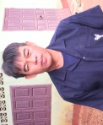  Mr. Bounchan  Khemmalath | 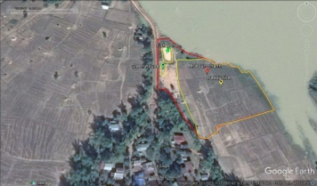 | 1) paddy rice; vegetables (regarding to local market); 3) Forage (B. ruzi+S. guianensis) ; 4) integrated cropping systems (fruit trees with one month banana and vegetables); 5) fish pond and 6) organic fertilizer production including water, soil and nutrient management
2 | Kudchab village  Nongbok District  Khammuon Province | 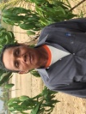  Mr. Boundo | 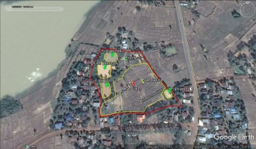 | 1) paddy rice; vegetables (regarding to local market); 3) Forage (B. ruzi+S. guianensis) ; 4) integrated cropping systems (fruit trees with one month banana and vegetables); 5) fish pond and 6) organic fertilizer production including water, soil and nutrient management
3 | Donkhiew village  Nongbok District  Khammuon Province | 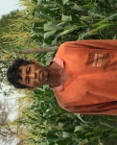  Mr. Vinit | 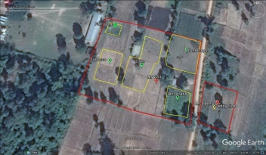 | 1) paddy rice; vegetables (regarding to local market); 3) Forage (B. ruzi+S. guianensis) ; 4) integrated cropping systems (fruit trees with one month banana and vegetables); 5) fish pond and 6) organic fertilizer production including water, soil and nutrient management
4 | Noy village  Sebangfai District  Khammuon Province | Mr Chanon |  | 1) paddy rice; vegetables (regarding to local market); 3) Forage (B. ruzi+S. guianensis) ; 4) integrated cropping systems (fruit trees with one month banana and vegetables); 5) fish pond and 6) organic fertilizer production including water, soil and nutrient management
5 | Noy village  Sebangfai District  Khammuon Province | Mr Doungmany
6 | Sok village  Kaison District  Savannakhet Province | Mr. Thongsi |  | 1) paddy rice; vegetables (regarding to local market); 3) Forage (B. ruzi+S. guianensis) ; 4) integrated cropping systems (fruit trees with one month banana and vegetables); 5) fish pond and 6) organic fertilizer production including water, soil and nutrient management
7 | Phai village  Champhone District  Savannakhet Province | 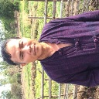  Mr Sesavan  Bangphachan | 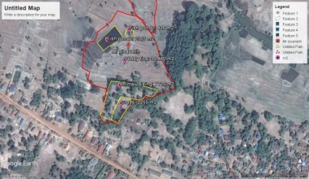 | 1) paddy rice; vegetables (regarding to local market); 3) Forage (B. ruzi+S. guianensis) ; 4) integrated cropping systems (fruit trees with one month banana and vegetables); 5) fish pond and 6) organic fertilizer production including water, soil and nutrient management
8 | Phai village  Champhone District  Savannakhet Province | Mr. Ki | 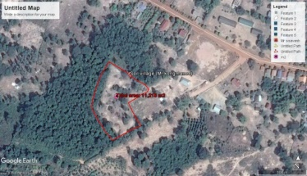 | 1) paddy rice; vegetables (regarding to local market); 3) Forage (B. ruzi+S. guianensis) ; 4) integrated cropping systems (fruit trees with one month banana and vegetables); 5) fish pond and 6) organic fertilizer production including water, soil and nutrient management
9 | Paksong village  Songkhon District  Savannakhet Province | Mr. Pheng |  | 1) paddy rice; vegetables (regarding to local market); 3) Forage (B. ruzi+S. guianensis) ; 4) integrated cropping systems (fruit trees with one month banana and vegetables); 5) fish pond and 6) organic fertilizer production including water, soil and nutrient management
10 | Kaison District  Savannakhet Province | Savannaket  University | 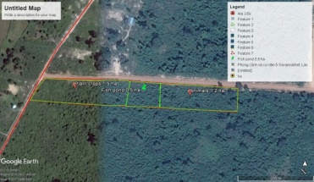 | 1) organic fertilizer testing with vegetables (compost, manure, biochar and others) ; 2) intergrated between crop and livestock ; 3) cash crop systmes (rice, sugarcan, maize, cassava integrated with legumes)
11 | Khonsay village  Rakhonpheng District  Salavan Province | 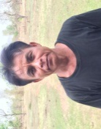  Mr. Vay | 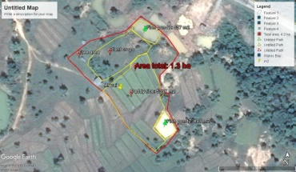 | 1) paddy rice; vegetables (regarding to local market); 3) Forage (B. ruzi+S. guianensis) ; 4) integrated cropping systems (fruit trees with one month banana and vegetables); 5) fish pond and 6) organic fertilizer production including water, soil and nutrient management
12 | Houykaphoxay village  Rakhonpheng District  Salavan Province | Mrs. Saisamone | 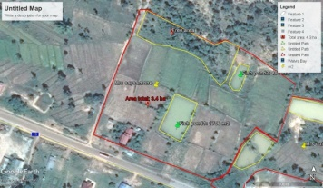 | 1) paddy rice; vegetables (regarding to local market); 3) Forage (B. ruzi+S. guianensis) ; 4) integrated cropping systems (fruit trees with one month banana and vegetables); 5) fish pond and 6) organic fertilizer production including water, soil and nutrient management
13 | Houykaphoxay village  Rakhonpheng District  Salavan Province | Mrs. Udtala | 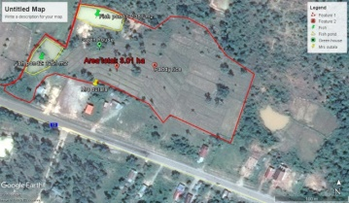 | 1) paddy rice; vegetables (regarding to local market); 3) Forage (B. ruzi+S. guianensis) ; 4) integrated cropping systems (fruit trees with one month banana and vegetables); 5) fish pond and 6) organic fertilizer production including water, soil and nutrient management
14 | Houykaphoxay village  Rakhonpheng District  Salavan Province | Mr. May |  | 1) paddy rice; vegetables (regarding to local market); 3) Forage (B. ruzi+S. guianensis) ; 4) integrated cropping systems (fruit trees with one month banana and vegetables); 5) fish pond and 6) organic fertilizer production including water, soil and nutrient management
- GWM Model in Lao PDR
Divided the field into 4 parts (ratio 30:30:30:10) including
- 30 Pond
- Water saving for all year round
- Fish Aquaculture to increase more income
- At the edge of the pond growing vetiver grass to protect soil erosion

- 30 Paddy Field
- One crop/year
- Storage for year round consumption
- 30 Trees/crops
- Fruits trees
- Perennial trees
- Annual trees
- Herb and spice
- Multi-purpose trees
- Field crops
- 10 Residential
- Other activities: vegetable, herb, mushroom, livestock

